**R assignment 2**

**1.a.**   
the easiest item is item number 5 which was -1,63  
the hardest item is item number 10 which was 0,53

**1.b.**   
left

[1] -0.06047327

> right

[1] 0.1732811

**1.c**   
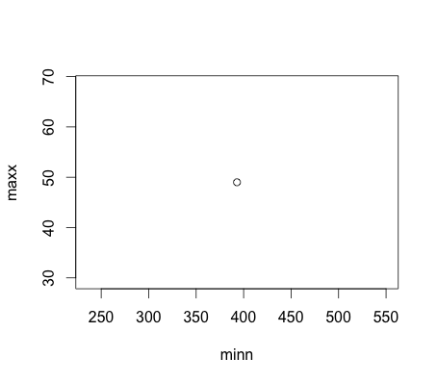

**1.e**   
The minium score was -3.999947  
The maxium score was 3.999921